AWS Asssignment 4

Task 1
Lauch 3 instances with the following tags respectively
- Name: nginx, boot-order: 1
- Name: myapp, boot-order: 2
- Name: mydb, boot-order: 3
Solution:

- Launch three instances namely nginx, myapp, mydb and add tag (boot-order) with their respective values.
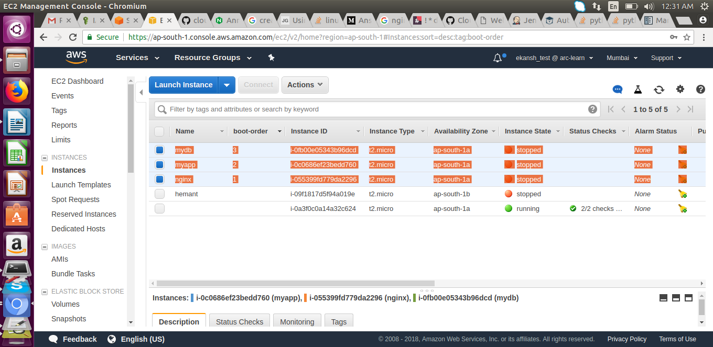
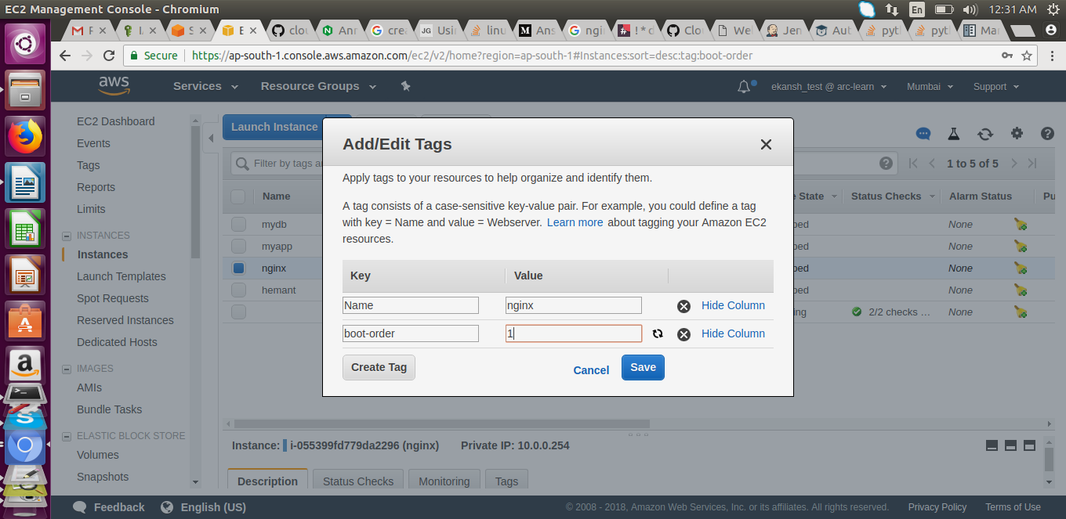

Task 2
write a script that would start/stop these instances in the order you specified, i.e.
- instance with boot-order: 3 tag should boot/start first and likewise rest of them
- instance with boot-order: 1 tag should stop first and likewise rest of them

Solution:
- write down a python script namely aws.py which will start and stop the instances as per requirement.
- Before that created an ima user(or used old one where the instance exists) and configured it the system from where the script to be run.
#!/usr/bin/env python
import boto3
import time
import sys
ec2 = boto3.resource('ec2')
client = boto3.client('ec2')

def stopInstances():

for instance in ec2.instances.all():
for tag in instance.tags:
if tag['Key'] == 'Name':
if tag['Value'] == 'nginx' or tag['Value'] == 'myapp' or tag['Value'] == 'mydb':
client.stop_instances(InstanceIds=[instance.id], DryRun=False)
instance.wait_until_stopped()
startInstancesInSeries(3)

def startInstancesInSeries(i):
for instance in ec2.instances.all():
for tag in instance.tags:
if tag['Key'] == 'boot-order':
if tag['Value'] == str(i):
print str(i)
client.start_instances(InstanceIds=[instance.id], DryRun=False)
instance.wait_until_running()
instance.reload()
print instance.state
startInstancesInSeries(i-1)

stopInstancesInSeries(1)

def stopInstancesInSeries(i):
if str(i) <= '3':
for instance in ec2.instances.all():
for tag in instance.tags:
if tag['Key'] == 'boot-order':
if tag['Value'] == str(i):
print str(i)
client.stop_instances(InstanceIds=[instance.id], DryRun=False)
instance.wait_until_stopped()
instance.reload()
print instance.state
stopInstancesInSeries(i+1)
else:
sys.exit(0)

stopInstances()

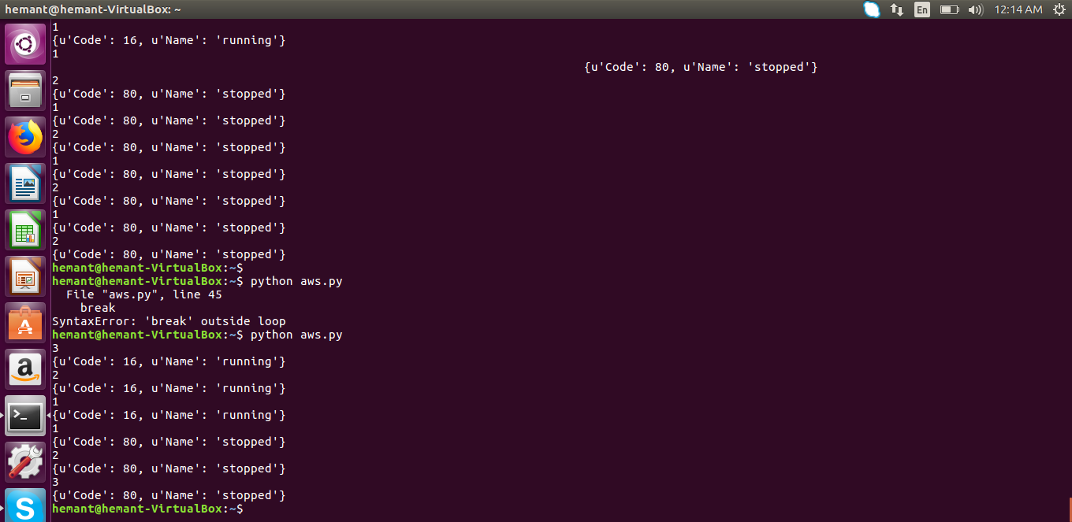

Task 3
Launch an ec2 instance with user-data having ansible role to host a website - [like previous assignment]
Figure out a way to launch this instance in your friend's AWS account

- Created an instance namey webRun with user data as:

#!/bin/bash
sudo apt-get update -y
sudo apt-get install software-properties-common -y
sudo apt-add-repository ppa:ansible/ansible -y
sudo apt-get update -y
sudo apt-get install ansible -y
sudo mkdir ansible
cd ansible
sudo wget https://s3.amazonaws.com/hemanthtml/hemant.html
sudo wget https://s3.amazonaws.com/ansibleplaybook/nginx.yml
sudo ansible-playbook nginx.yml
sudo mv hemant.html /var/www/html/index.nginx-debian.html
sudo systemctl restart nginx

- Stop this instance and created copy of this AMI
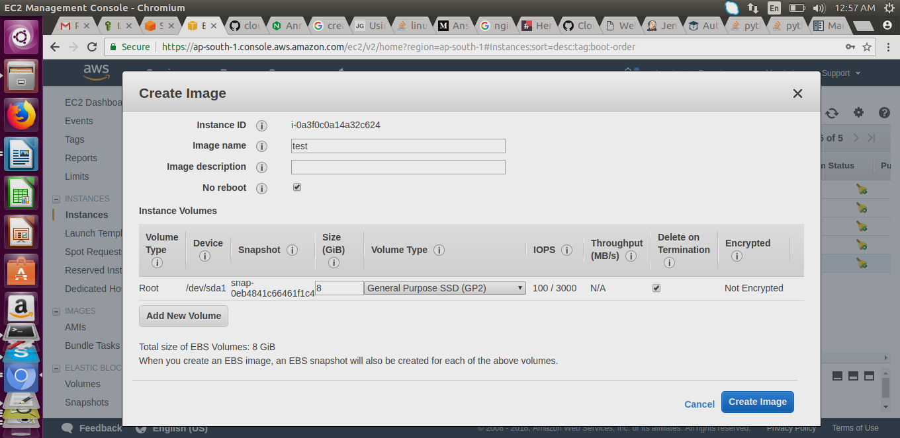
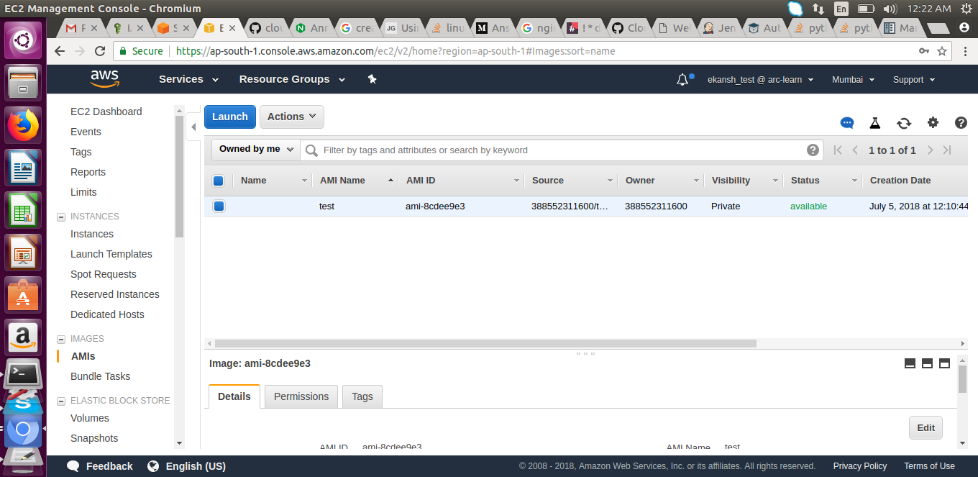

iii. Go to action tab > modify image permission > add awd account id of friend
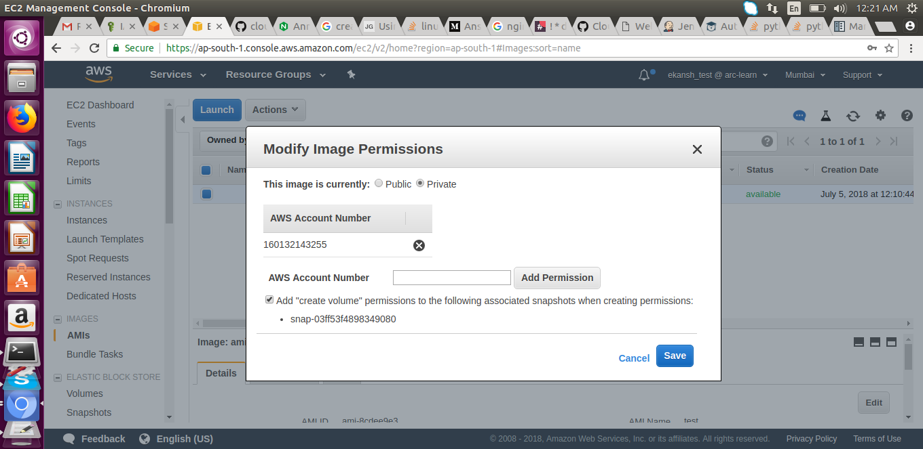
iv. Login with friend aws account and launch the ami from ec2 (images under side navigation tab)

